- Login dengan ssh client :
ssh root@165.22.54.66
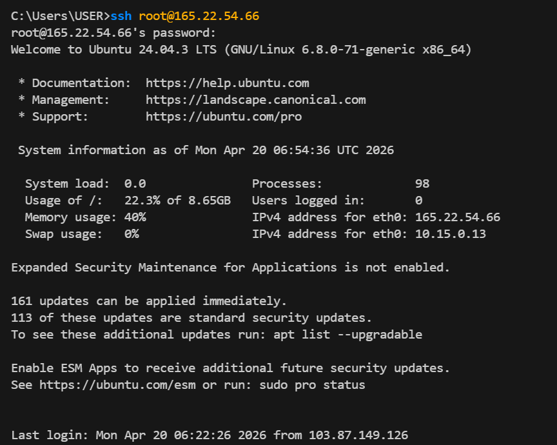
- Jalankan :
#apt update
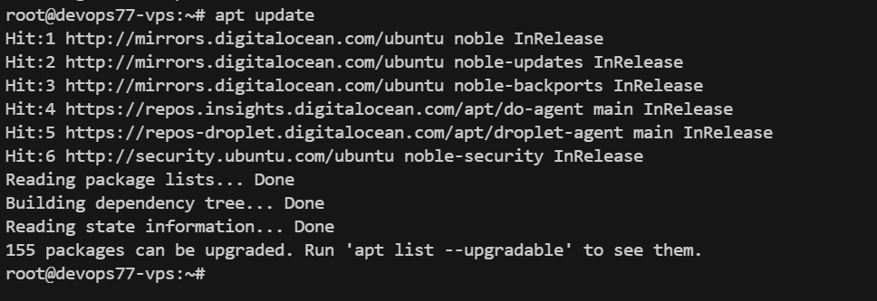
- Jalankan :
#apt upgrade -y
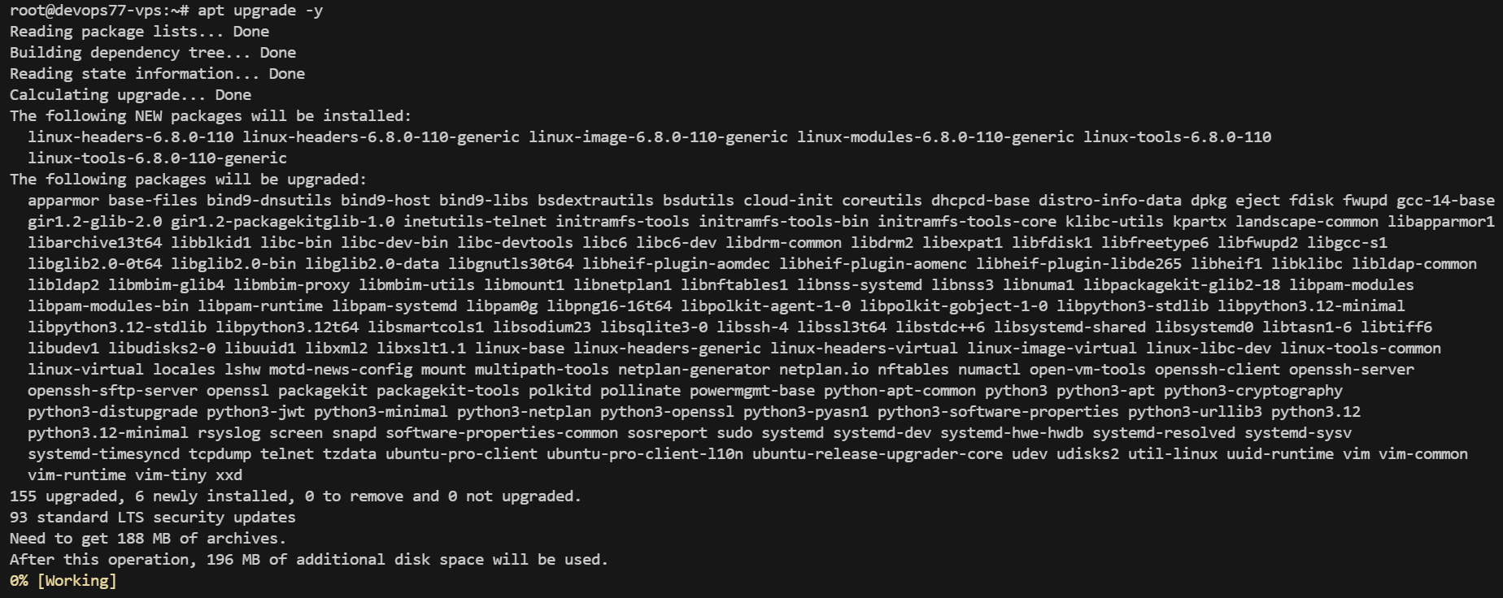
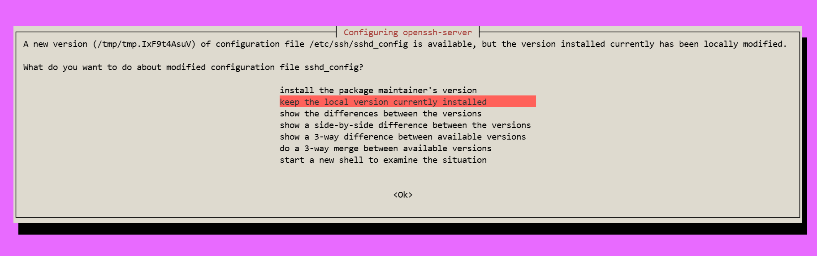
Restarting services...
systemctl restart cron.service

Service restarts being deferred:
/etc/needrestart/restart.d/dbus.service
systemctl restart getty@tty1.service
systemctl restart serial-getty@ttyS0.service
systemctl restart systemd-logind.service
systemctl restart unattended-upgrades.service

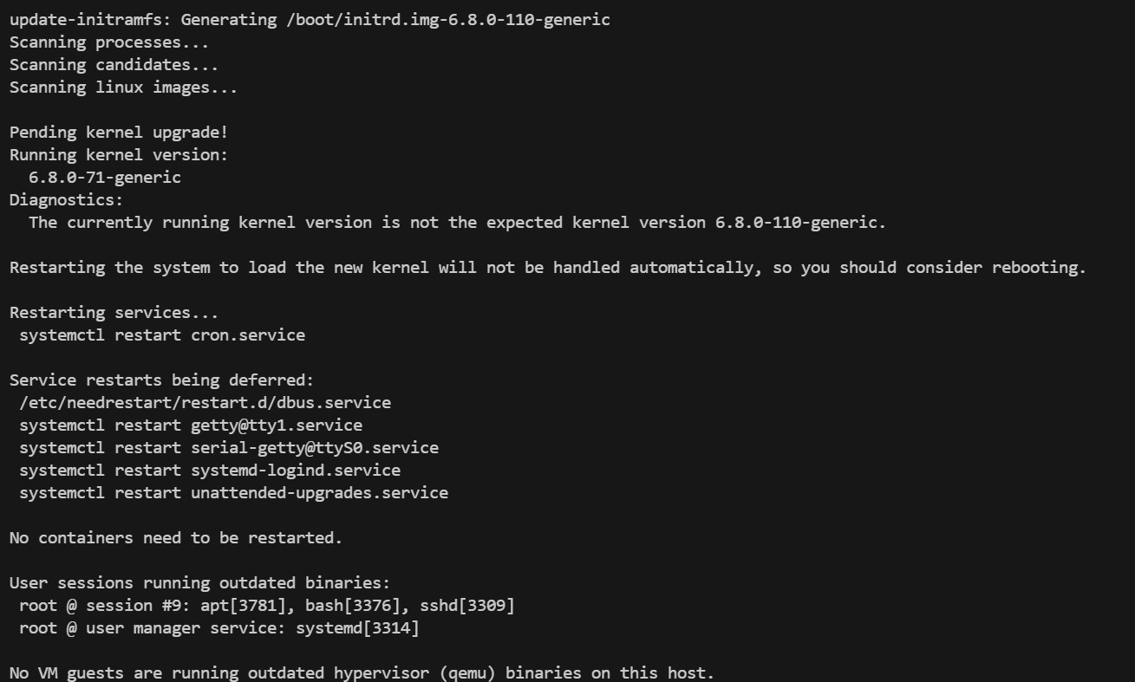
- Untuk setup swap file, cek terlebih dahulu apakah ada swap file.
# free -h
total used free shared buff/cache available
Mem: 458Mi 185Mi 47Mi 4.0Mi 250Mi 273Mi
Swap: 0B 0B 0B

- Buat swap file dengan Langkah-langkah sbb :
#fallocate -l 2G /swapfile
- Set permission file swapfile:
#chmod 600 /swapfile
- Format sebagai swap:
#mkswap /swapfile
- Activate swap:
#swapon /swapfile
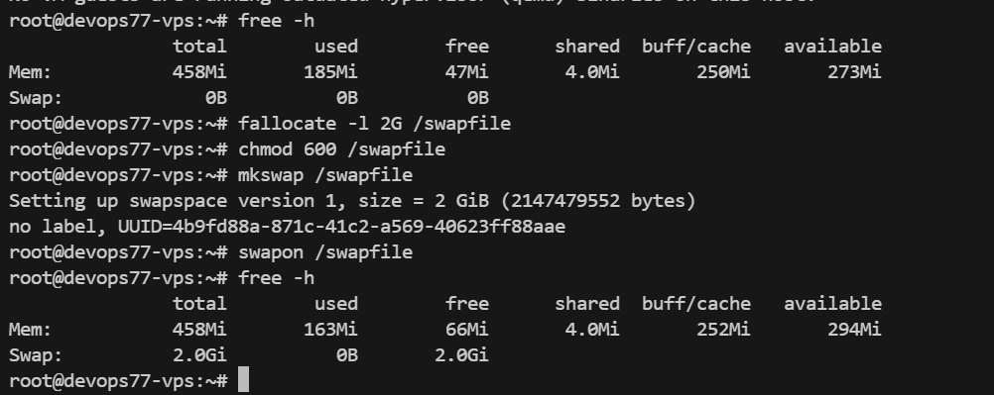
- Buat swapfile permanent diload setiap kali server booting.
#vi /etc/fstab
Tambahkan /swapfile none swap sw 0 0
Save file /etc/fstab.
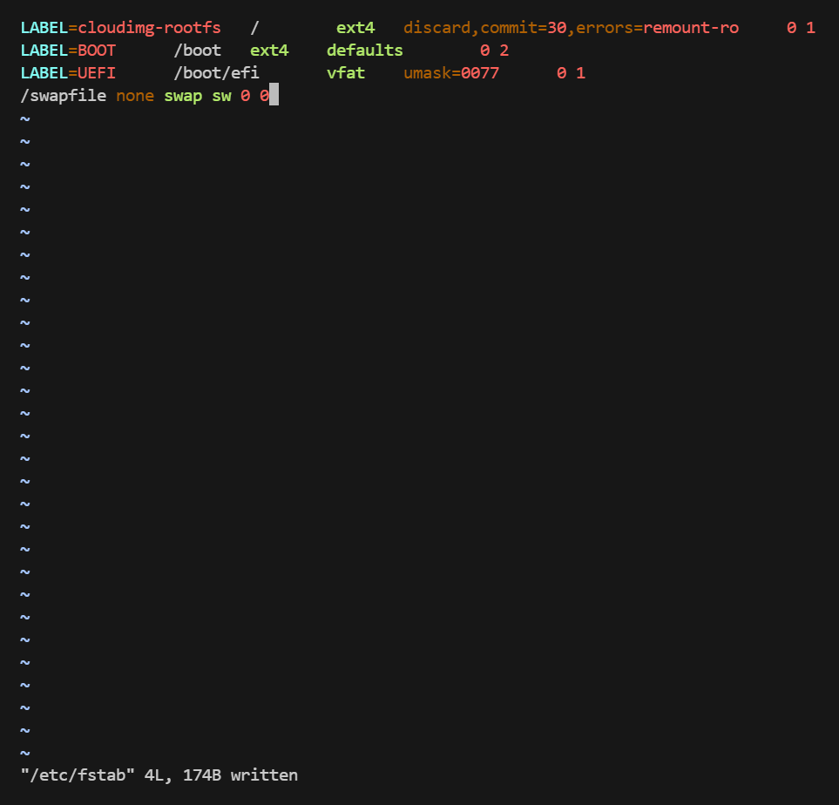
- Cek apakah swap file sudah aktif :
- Free -h
total used free shared buff/cache available
Mem: 458Mi 163Mi 66Mi 4.0Mi 252Mi 294Mi
Swap: 2.0Gi 0B 2.0Gi

- Selesai.

